NCDA Speakers’ Bureau
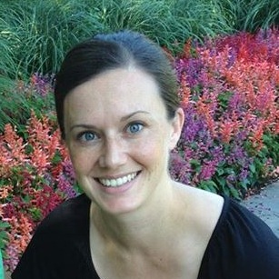

Brie Weiler Reynolds, M.S.
Dallas, TX
866-991-9222 x709
brie@flexjobs.com
www.flexjobs.com

Brief Bio: Brie Weiler Reynolds is a former college career advisor and an expert in the telecommuting and flexible job market. Her speaking engagements have included audiences of job seekers, employers and recruiters, and career counselors.

Brie spent five years as a Career Advisor the Internships and Career Development Office at Emmanuel College in Boston before becoming the Director of Online Job Content for FlexJobs. Today, Brie specializes in creating content and conducting webinars related to the flexible job market, including the topics of telecommuting/at-home jobs, flexible scheduling, professional part-time jobs, and jobs for groups like boomers/retirees, moms returning to the workforce, and millennials.

Presentation Titles: How to Start Telecommuting / Working from Home
Trends in the Work-from-Home Job Market
How to Find a More Flexible Job
Negotiating a Flexible Work Arrangement
Great Job Options for Retirees

**Brie is happy to work with you for a more personalized presentation related to flexible work arrangements and the flexible job market.**

Fee: No fee

Format: Speaker, Panel Presentations, Webinars, Skype
Interviews, Google Hangouts

Length of Session: Flexible to fit your group’s needs

Availability: Year-round

Follow-up: Consultation on Presentation Topic

