National Career Development Association
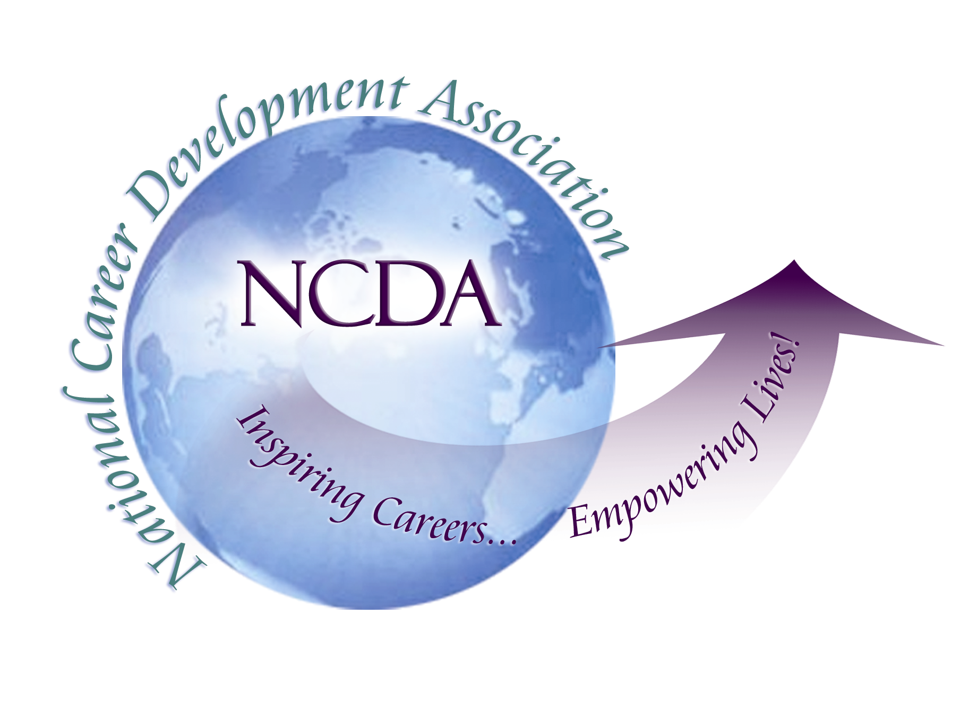
305 N. Beech Circle
Broken Arrow, OK 74012
918/663-7060
Fax: 918/663-7058
www.ncda.org

National Career Development Association
Leadership Academy
Action Learning Project Summary

Participant(s): Kristin Conner

Board Mentor: Michelle Beese

Leadership Academy Class: 2013-2014

Project Title: Assessment and Exploration of Leadership Academy Experiences

Project Description:
My project was to develop an online survey which was sent to past and current Leadership Academy (LA) participants. The focus of the survey questions was to understand the learning and benefits from participating in the LA training, any changes or additions they suggest for the program, in what way it prepared and encouraged them to pursue leadership positions in NCDA, and any contribution they personally would like to add to the program in future years. Depending on recommendations and availability of past LA participants attending NCDA at Long Beach, changes could be implemented for the next Leadership Academy cohort beginning in Long Beach. The benefits to NCDA would be a stronger Leadership Academy program producing stronger leaders for NCDA, and continued and sustained involvement by past Leadership Academy participants which also produces stronger leaders for NCDA’s future. The developed survey could be used annually to make sure the program outcomes are sustained.

Summary/Conclusion:
The survey was sent to 88 current and past LA participants with 42 completing the survey. Results of the survey indicate 53% of Leadership Academy participant felt the training/participation in the Leadership Academy met their expectations. Only a combined 14% felt the training exceeded or far exceeded expectations, while 32% felt the training fell short or far short of expectations. This shows that the training is adequate for most, although the number that was dissatisfied was larger than the number very satisfied which means there could be some areas to improve.
A large number (54%) of Leadership Academy participants reported participating in future task forces or committees which show there was motivation and encouragement toward more involvement with NCDA. When looking at more specific leadership at the state or board level the number that pursued those roles drops to 16% – 19%. There still may be hesitancy or feeling of not being prepared that may prevent LA participants from seeking greater leadership involvement. In turning the focus to the actual training topics, the reported most useful part (74%) of the Leadership Academy was the networking with other participants and board members. The most requested topic that participants would have liked (or liked more) training on was strategies for leadership and management at 58%. Overall conclusions are that while the Leadership Academy is satisfactory to most participants, their actual pursuit of state and NCDA Board-level leadership is low. The fact that the highest ranked training topic requested was on strategies for leadership and management indicates an interest by LA participants in pursuing higher level leadership roles, but likely they still feel unprepared to take on the challenge. As the board moves forward a closer look at the purpose of the Leadership Academy may be necessary. It encourages and enhances involvement in NCDA which is a benefit to all, but if the true focus is to get more state or national leaders a stronger and more focused training will be necessary.
Please see attached survey results for full respondent reporting and results.

Results/Recommendations:
Before this project was completed, the Leadership Academy task force was given information from the survey that listed past LA alumni who indicated interest in being more involved during NCDA Long Beach conference. Minimally these alumni can be invited to the alumni networking reception at the conference.
Additional recommendations collected from current and past LA participants in the survey include strengthening training by involving more past Leadership Academy alumni or other NCDA member. The following were the top ranked and requested training topics/ additional information that current and past LA participants would have liked in their training and therefore would be useful for future cohort:

- Strategies for membership recruitment/retention
- Strategies for leadership and management of groups
- Networking with NCDA Board leadership and other LA participants
- More information on future direction of NCDA
- Professional leadership opportunities in NCDA and beyond
- Advocacy for NCDA and related issues
- Financial management for leadership roles

Other individual suggestions from survey respondents:
- More time to identify and connect with project mentors
- Added role on board to oversee Leadership Academy
- Stronger inclusion of 2nd year Leadership Academy cohort in training of 1st year cohort

Survey Questions and Responses
1. What prompted you to participate in the Leadership Academy?
# | Answer |  | Response | %
1 | Learn about new state/national leadership opportunities |  | 20 | 47%
2 | Learn about issues facing state/national leadership groups |  | 17 | 40%
3 | Learn about opportunities to serve on committees and task forces |  | 18 | 42%
4 | Gain knowledge on a specific leadership skill |  | 8 | 19%
5 | Networking opportunities |  | 24 | 56%
6 | Other: |  | 12 | 28%

Other:
The benefits! Working for a small nonprofit it wasn't in our budget to send me to conferences. LA was a way to afford to be a part of NCDA and I was happy to be able to contribute in return.
Financial incentive
To learn about best practices and more about NCDA
To assist with national issues, not just learn about them.
learn more about the association and how I might contribute
Fully immerse myself in the workings of NCDA
Get more involved in NCDA, having concluded my term as president of my state cda
Study options on online professional development via NCDA
Develop as a Leader in Career Development
Service to others

Statistic | Value
Min Value | 1
Max Value | 6
Total Responses | 43

2. To your recollection, what topics of leadership were covered during the LA meetings at the NCDA conference(s)?
# | Answer |  | Response | %
1 | Presentations by current Leadership Academy cohort |  | 39 | 91%
2 | History of NCDA/Governance |  | 31 | 72%
3 | Future directions of NCDA |  | 27 | 63%
4 | Advocacy for NCDA and related issues |  | 22 | 51%
5 | Financial management for leadership roles |  | 10 | 23%
6 | Personal career stories from NCDA Board leadership or others in leadership roles |  | 17 | 40%
7 | Networking with NCDA Board leadership and other LA participants |  | 36 | 84%
8 | Strategies for leadership and management of groups |  | 7 | 16%
9 | Strategies for membership recruitment/retention |  | 7 | 16%
10 | Overview of State/National organizational structure |  | 28 | 65%
11 | Strategies for event planning |  | 2 | 5%
12 | Professional leadership opportunities in NCDA and beyond |  | 27 | 63%
13 | Other: |  | 0 | 0%

Other:

Statistic | Value
Min Value | 1
Max Value | 12
Total Responses | 43

3. To what extent were your expectations of the Leadership Academy training met?
# | Answer |  | Response | %
1 | Far short of expectations |  | 1 | 2%
2 | Short of expectations |  | 13 | 30%
3 | Met expectations |  | 23 | 53%
4 | Exceeded expectations |  | 2 | 5%
5 | Far exceeded expectations |  | 4 | 9%
 | Total |  | 43 | 100%

Statistic | Value
Min Value | 1
Max Value | 5
Mean | 2.88
Variance | 0.82
Standard Deviation | 0.91
Total Responses | 43

4. What part of the training did you find the most useful (please pick up to 5)
# | Answer |  | Response | %
1 | Presentations by current Leadership Academy cohort |  | 26 | 60%
2 | History of NCDA/Governance |  | 11 | 26%
3 | Future directions of NCDA |  | 20 | 47%
4 | Advocacy for NCDA and related issues |  | 10 | 23%
5 | Financial management for leadership roles |  | 1 | 2%
6 | Personal career stories from NCDA Board leadership or others in leadership roles |  | 11 | 26%
7 | Networking with NCDA Board leadership and other LA participants |  | 32 | 74%
8 | Strategies for leadership and management of groups |  | 3 | 7%
9 | Strategies for membership recruitment/retention |  | 1 | 2%
10 | Overview of State/National organizational structure |  | 11 | 26%
11 | Strategies for event planning |  | 2 | 5%
12 | Professional leadership opportunities in NCDA and beyond |  | 16 | 37%
13 | Other: |  | 7 | 16%

Other:
opportunities to discuss the action learning project with other LA participants, NCDA Board leadership, and mentors
networking with like minded colleagues
Much deeper understanding of the workings of NCDA
networking with other LA candidates which resulted in research and publication opportunities for me
Establishing a mentoring circle
having the support of NCDA to conduct my research associated with the project.
The project allowed me to develop a solid relationship with a fellow leader and information on how to publish your work in NCDA materials was really helpful

Statistic | Value
Min Value | 1
Max Value | 13
Total Responses | 43

5. What areas of leadership information would you have liked covered (or covered in more depth) during the training? (please pick up to 5)
# | Answer |  | Response | %
1 | Presentations by current Leadership Academy cohort |  | 5 | 12%
2 | History of NCDA/Governance |  | 5 | 12%
3 | Future directions of NCDA |  | 18 | 42%
4 | Advocacy for NCDA and related issues |  | 16 | 37%
5 | Financial management for leadership roles |  | 14 | 33%
6 | Personal career stories from NCDA Board leadership or others in leadership roles |  | 10 | 23%
7 | Networking with NCDA Board leadership and other LA participants |  | 18 | 42%
8 | Strategies for leadership and management of groups |  | 25 | 58%
9 | Strategies for membership recruitment/retention |  | 19 | 44%
10 | Overview of State/National organizational structure |  | 6 | 14%
11 | Strategies for event planning |  | 12 | 28%
12 | Professional leadership opportunities in NCDA and beyond |  | 18 | 42%
13 | Other: |  | 6 | 14%

Other:
Clarity on the long term plan and goals. I don't think I was ever really clear about what NCDA most needed.
Green Career Guidance directions
experiential activities that would help me determine how my strengths might meet the needs of the association
Specific steps for how to grow leadership role in NCDA
Functions of NCDA committees

Statistic | Value
Min Value | 1
Max Value | 13
Total Responses | 43

6. How helpful was the Leadership Academy in assisting in your development as a future leader in the national and state career development association?
# | Answer |  | Response | %
1 | Not helpful |  | 1 | 2%
2 | Somewhat helpful |  | 14 | 33%
3 | Indifferent |  | 4 | 9%
4 | Helpful |  | 13 | 30%
5 | Extremely helpful |  | 11 | 26%
 | Total |  | 43 | 100%

Statistic | Value
Min Value | 1
Max Value | 5
Mean | 3.44
Variance | 1.59
Standard Deviation | 1.26
Total Responses | 43

7. What, if any, leadership roles did you pursue as a result of the Leadership Academy?
# | Answer |  | Response | %
1 | Leadership role in local chapter of NCDA |  | 2 | 5%
2 | Leadership role in state chapter of NCDA |  | 7 | 16%
3 | Leadership role on NCDA board |  | 8 | 19%
4 | Committee or Task force |  | 23 | 53%
5 | Conference planning committee for local, state, or national NCDA event |  | 4 | 9%
6 | Did not seek leadership role as a result of Leadership Academy |  | 7 | 16%
7 | Other: |  | 13 | 30%

Other:
I've done a bit of research with a group overseas addressing green career counseling. I was hoping to find colleagues here in the states who would wish to do research on this topic (green/sustainability), but haven't as of yet.
I had already been State president
continued with California CDA leadership role
APCDA
Editorial role with NCDA publication
Already a leader in several organizations
research and publications
Already in leadership role. Strengthen current role as a leader
Changed personal circumstances prevented a more active role.
Presenting at a future conferene
Aca division
CDQ Editorial Board

Statistic | Value
Min Value | 1
Max Value | 7
Total Responses | 43

8. In growing and incorporating LA alumni in future training, what training topics/events, if any, do you feel you could contribute to future Leadership Academy trainings and meetings?
# | Answer |  | Response | %
1 | Assisting with current Leadership Academy cohort projects |  | 18 | 42%
2 | History of NCDA/Governance |  | 0 | 0%
3 | Future directions of NCDA |  | 7 | 16%
4 | Advocacy for NCDA and related issues |  | 6 | 14%
5 | Financial management for leadership roles |  | 1 | 2%
6 | Personal career stories from NCDA Board leadership or others in leadership roles |  | 13 | 30%
7 | Networking with NCDA Board leadership and other LA participants |  | 21 | 49%
8 | Strategies for leadership and management of groups |  | 11 | 26%
9 | Strategies for membership recruitment/retention |  | 11 | 26%
10 | Overview of State/National organizational structure |  | 1 | 2%
11 | Strategies for event planning |  | 9 | 21%
12 | Professional leadership opportunities in NCDA and beyond |  | 10 | 23%
13 | Not able to contribute at this time |  | 7 | 16%
14 | Other: |  | 4 | 9%

Other:
Something at the state level
limited but as needed by topic area
Forming a new NCDA committee

Statistic | Value
Min Value | 1
Max Value | 14
Total Responses | 43

9. If attending the NCDA at Long Beach, would you be willing to contribute to training or other networking/mentoring events?
# | Answer |  | Response | %
1 | Yes |  | 31 | 72%
2 | No |  | 12 | 28%
 | Total |  | 43 | 100%

Statistic | Value
Min Value | 1
Max Value | 2
Mean | 1.28
Variance | 0.21
Standard Deviation | 0.45
Total Responses | 43

10. If you answered yes to the previous question, please indicate which areas you would be willing to contribute to:
# | Answer |  | Response | %
1 | Assisting with current Leadership Academy cohort projects |  | 13 | 43%
2 | History of NCDA/Governance |  | 0 | 0%
3 | Future directions of NCDA |  | 4 | 13%
4 | Advocacy for NCDA and related issues |  | 5 | 17%
5 | Financial management for leadership roles |  | 2 | 7%
6 | Personal career stories from NCDA Board leadership or others in leadership roles |  | 10 | 33%
7 | Networking with NCDA Board leadership and other LA participants |  | 14 | 47%
8 | Strategies for leadership and management of groups |  | 9 | 30%
9 | Strategies for membership recruitment/retention |  | 5 | 17%
10 | Overview of State/National organizational structure |  | 1 | 3%
11 | Strategies for event planning |  | 5 | 17%
12 | Professional leadership opportunities in NCDA and beyond |  | 2 | 7%
13 | Other: |  | 2 | 7%

Other:
I'm willing to help in any way that you need me
wherever needed

Statistic | Value
Min Value | 1
Max Value | 13
Total Responses | 30

11. Did you attend the Leadership Academy Networking Event at NCDA Boston? Why/Why not?
# | Answer |  | Response | %
1 | Yes |  | 28 | 67%
2 | No |  | 14 | 33%
 | Total |  | 42 | 100%

Yes | No
Networking. Give back | I ended up being double-booked. :-(
missed most of it b/c I had the wrong time! Very disappointed that I wasn't able to participate more fully. | Wanted to, but it conflicted with anotherconference commitment
Networking | couldn't afford the expense
I wanted to see past alums | My family took vacation in Boston, so I was splitting my time.
I was a current LA member in 2013 | I believe it was at the same time as the PDI I attended.
Networking, saying hi to friends | not in my budget last year
To stay current/connected | Did not attend conference
Part of my current LA class curriculum, and a good chance to network and share ideas. | schedule conflict
Enjoyed connecting! | Chose a different conference due to a new leadership role in MPACE
Presentation to LA alumni | Did not attend conference
Meet with fellow Leadership Academy Participants | Conflict
I saw it as vital to the training. | I am now an Internship Professional and attend other Professional Conferences so I couldn't be in Boston at the Conference
Felt obligation to LA
networking and catching up with friends
I'm glad we had it.
Networking
Wonderful way to connect

Statistic | Value
Min Value | 1
Max Value | 2
Mean | 1.33
Variance | 0.23
Standard Deviation | 0.48
Total Responses | 42

12. Please indicate other comments or suggestions you would like to add regarding the Leadership Academy training?
Text Response
I would like to see LA projects tied to the goals of the NCDA long term strategic plan.
offering scholarships so some could attend
I think that the LA should be run by someone(s) other than a Trustee (they have to much to do) this would provide another leadership opportunity to a LA grad(s) or someone else within the organization
I would like to see continued networking for LA alumni
I am not sure if I can come to CA this year....based on paying persona costs and schedule issues.
Overall, the experience was fantastic. However, we needed to complete a project for the NCDA LA and I was given a mentor that didn't have the time or interest in my project. So, I would just suggest to really make sure you are picking mentors who are invested and engaged. It was highly frustrating. Then, I joined a committee and the entire committee was interested in working on my project but the leader had her own agenda so it was dismissed. Therefore, I stopped participating in leadership roles with NCDA. I have not closed that door though, and currently serve on a task force.
I'd love to brainstorm possible projects/ways in which LA alums could contribute to moving NCDA forward
More training on management skills needed for leadership in professional organizations.
I wish I could help this year in Long Beach but will not be attending. I plan to attend NCDA in 2015. I would like to be more involved with NCDA.
More leadership-specific coaching would be great. In my training, we talked about Strengths Finder, but covered it very briefly, so it would have been nice to dive deeper into the self-assessment aspects of leadership development.
Wonderful opportunity. Support continued growth in this area
Needs to integrate better with the NCDA board
Form Long term mentoring groups
I am unsure at this time if I will be at the Long Beach Conference, but I hope to attend!
Projects should be determined by the NCDA Board in advance to ensure "results and recommendations" are embraced and implemented and participants should be identified/recruited for their ability to contribute to particular projects identified by the Board. More training regarding NCDA operations; Board activities/roles; and leadership skills for projects, teams, organizations, etc. should be provided.

Statistic | Value
Total Responses | 15

13. If you would like to be contacted to assist with the Leadership Academy training meetings at Long Beach or future NCDA conferences please include your name and contact information.
Name | Title | Organization | Email
Information Deleted to Protect Privacy – Information sent to LA Training Taskforce

Statistic | Value
Total Responses | 27

