NCDA Speaker's Bureau
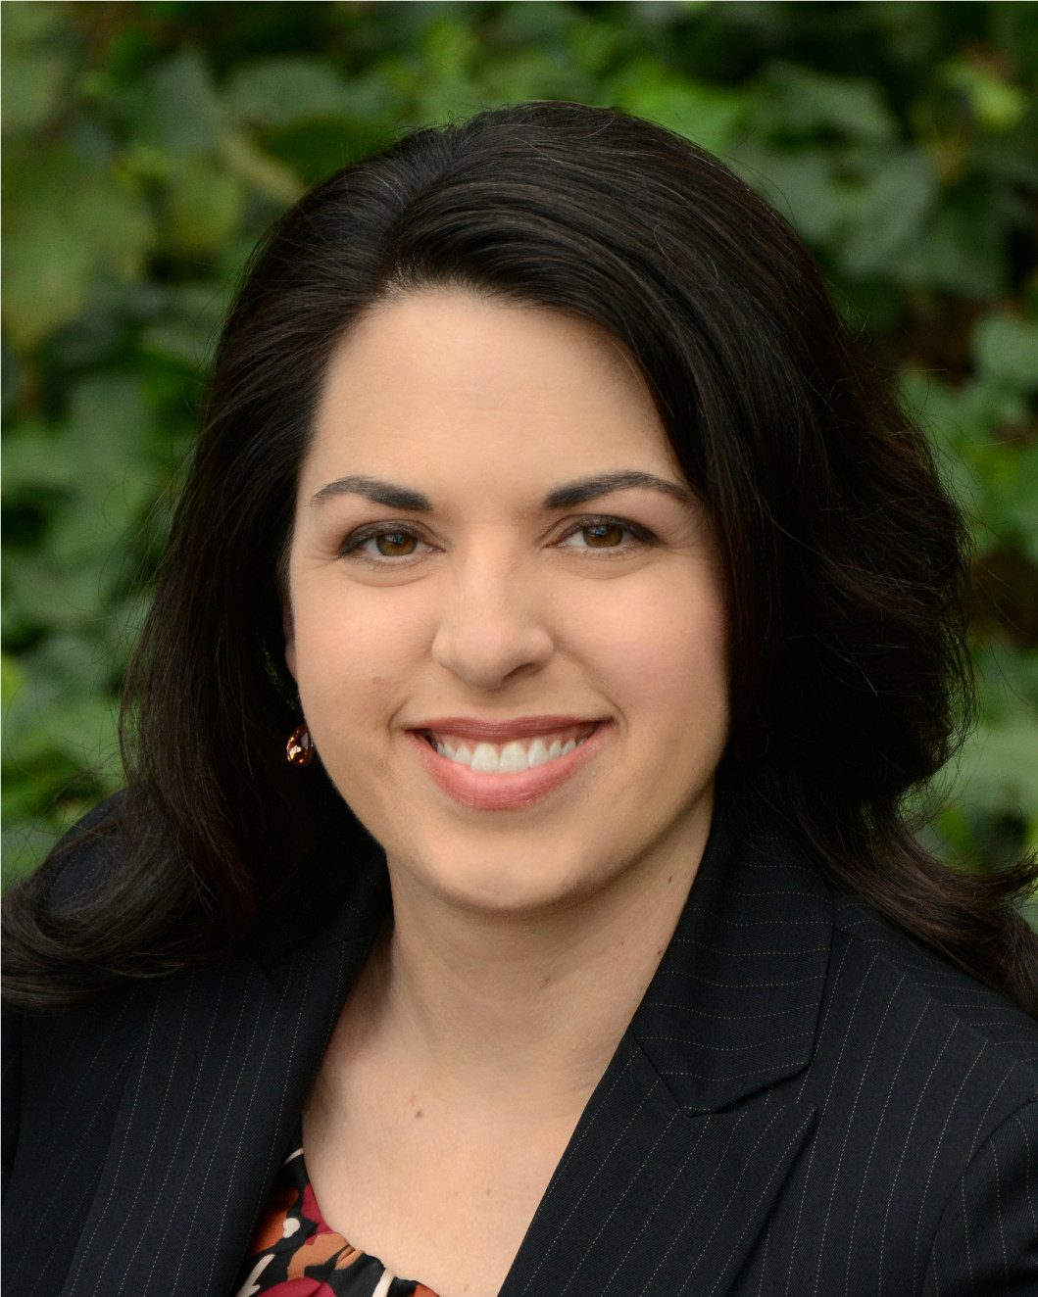
Complete Contact info:

Mary Konow, MS, GCDF
Career Counselor & Owner
MK Career Designs

Mary@MKCareerDesigns.com
www.MKCareerDesigns.com
(916) 900-6019

Brief Bio:
Mary Konow is a Career Counselor, a Certified Global Career Development Facilitator and owner of MK Career Designs, an executive career counseling practice based in Northern California.

Through individual one-on-one career strategy sessions, career document development services and career readiness workshops, her clients regularly experience “aha!” moments that empower them towards their career goals.

She serves a growing executive clientele, both locally and internationally, within a wide range of industries including: business management, IT, public service, education, agriculture, criminal justice, non-profit, finance, marketing and sales. The best part of her job is helping job seekers get “unstuck,” gain confidence and polish the skills to that position them for success.

Presentation Titles:
She loves speaking to groups about various Career Readiness Issues. Her original presentations include:
- Networking Strategies for the Savvy Jobseeker
- Online Job Search Strategies: Conquer the Online Applications!
- Career Branding & YOU: Get Noticed and Get Ahead!
- Effective Strategies for Career Transitions
- LinkedIn Strategies for Career Advancement
- Sector Switch: Transitioning to the Nonprofit World

Fee: Negotiable. Fee does not include travel, accommodations. Fees can be all inclusive.

Format: Keynotes: 30 – 60 minutes
Presentations/ Interactive Workshops: 1-3 hours
Webinars: 1-2 hours
Intensives: 1- 3 days

Length of Session: 1 - 3 hours, up to 3-day intensives depending on audience needs.

Follow-Up: One-on-One Follow-up Sessions are available as part of the program.

Availability: Year Round. Please inquire about availability 3-4 weeks in advance.

